This Transgender Awareness Week show your support with a Tie to Love
Commemorative bow tie celebrates community’s game changing pioneers

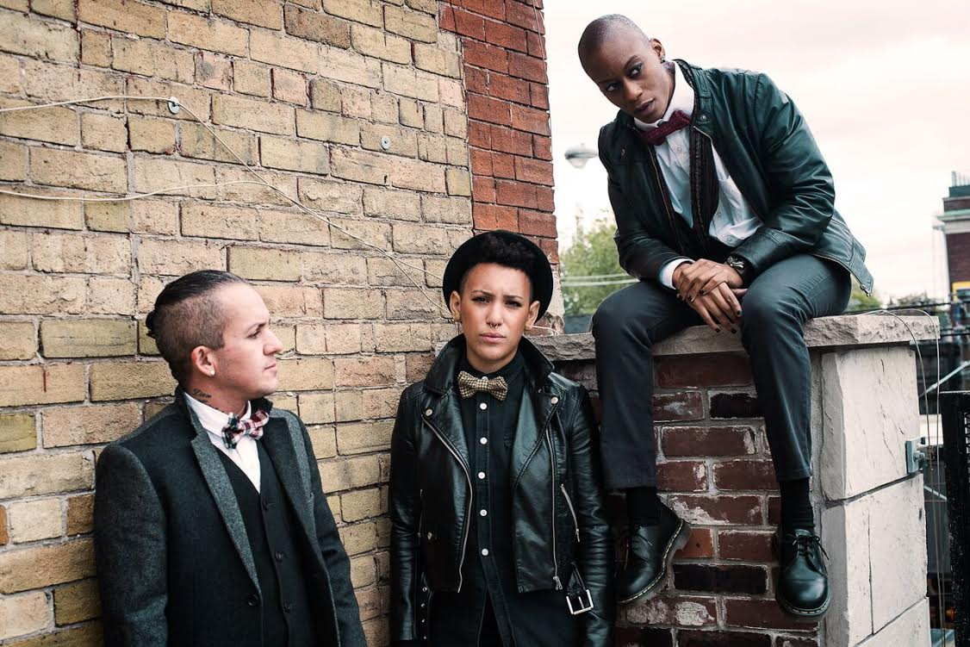

November 10, 2015, TORONTO – To mark Transgender Awareness Week 2015 (Nov.14-20), Jack Jackson of Alljackedup has designed a special, one-off commemorative bow tie celebrating the achievements of activists, pioneers and heroes of the transgender, gender variant and gender non-conforming communities.

Available for a limited time, the bow tie features the names of current transgender role models like actress Laverne Cox, adult film producer and performer Buck Angel, musicians Rae Spoon and Lucas Silveira and model Andreja Pejic, along with historic pioneers such as activists Marsha P. Johnson and Sylvia Rivera.

“These names are some of mine, but others may have different personal heroes,” says Jackson, who founded Alljackedup for the queer, androgynous and transmasculine fashion conscious in 2014. “The important thing is that we start a conversation.”

To keep the conversation going, Jackson encourages transgender people and allies alike to post a photos of themselves wearing their own bow ties during Transgender Awareness Week with the hashtag #TiesToLove.

Fifty per cent of the proceeds from the sale of the bow tie and all other Alljackedup products purchased during the week of Trans Day of Remembrance will go to Supporting Our Youth (SOY), a Toronto-based organization dedicated to improving the lives of gay, lesbian, bisexual, transgender, transsexual and intersex youth.

About Ties to Love™
The Ties to Love campaign (formally Bowtie Fridays) is an international movement of solidarity, love and support for the gender non-conforming and trans community. It aims to raise awareness of trans issues and to give back to queer and trans youth while encouraging community ties. The campaign runs regular competitions via the Facebook group, offering prizes donated by Alljackedup Inc., Toronto, and other community supporters. #TiesToLove

-30-

For more information,

Max Mosher, ClutchPR
max@clutchpr.com
1 416 588 9687

